**CENWP-ODJ7/19/2023**

**MEMORANDUM FOR THE RECORD**

**SUBJECT: *23JDA28 Sockeye Mort in Gatewell 12B***

On Tuesday 18 July 2023, at approximately 0900, JDA fisheries personnel found a sockeye mort in gatewell 12B. It was removed from the gatewell, scanned for PIT tags (no tag) and returned to the river. JDA fisheries personnel conduct gatewell inspections daily and will monitor this gatewell closely for any additional morts.

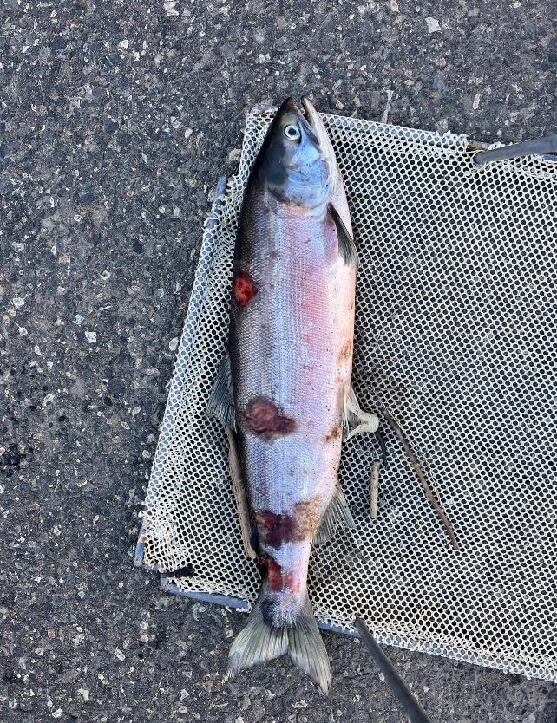

1. Species – Sockeye
2. Origin – Unclipped
3. Length – 26”
4. Marks and tags – N/A
5. Marks and Injuries found on carcass – Some descaling, fungus
6. Cause and Time of Death – Unknown
7. Future and Preventative Measures – N/A

Sincerely,

JDA Project Fisheries